


Experiment No.: 2

Title

8-Queen Problem using Python

Aim

To solve the 8-Queen problem using the Backtracking algorithm in Python.

Apparatus / Software Required

Computer or Laptop

Python 3.x

IDLE / VS Code / PyCharm (Any Python IDE)

Windows Operating System

Procedure

Open the Python IDE.

Create a new Python file.

Write the Python program for the 8-Queen problem.

Save the file with the .py extension.

Run the program.

The program places eight queens on the chessboard using backtracking.

Ensure that no two queens attack each other.

Display the final board configuration.

Verify the output.

Close the program.

Program
N = 8

board = [[0]*N for _ in range(N)]

def safe(row, col):

for i in range(col):

if board[row][i]:

return False

i, j = row, col

while i >= 0 and j >= 0:

if board[i][j]:

return False

i -= 1

j -= 1

i, j = row, col

while i < N and j >= 0:

if board[i][j]:

return False

i += 1

j -= 1

return True

def solve(col):

if col >= N:

return True

for i in range(N):

if safe(i, col):

board[i][col] = 1

if solve(col+1):

return True

board[i][col] = 0

return False

solve(0)

for row in board:

print(row)

Sample Output

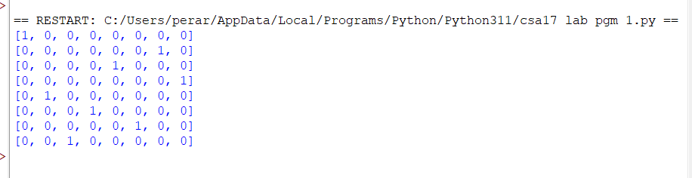

Result

Thus, the Python program to solve the 8-Queen Problem using the Backtracking algorithm was implemented successfully, and the required solution was obtained.

